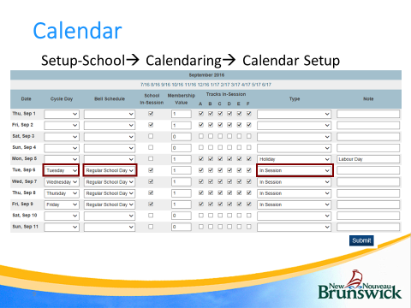

- EECD has made the first 5 days of each scheduling term (full year, S1, S2, Q1, Q2 etc…) as In Session for the purposes of scheduling. During the summer, when enrolling students into courses use July 13th as the enrollment date.
  - During the first week that students are back (Sept 6 ), EECD will wipe the July and Aug In Session days so that they are not included in student attendance.
- Set up Sept 6 – 30:
  - For each date:
    - Choose the correct day (High schools on 1 day cycle choose day A. Schools on Monday to Friday schedule choose the correct day etc)
    - Choose the correct Schedule (Choose the bell schedule used that day)
    - Choose the correct Type (In Session – if classes are in session. )
    - NOTE: If school is not in session (for example - holiday, storm day etc…) then for that day clear BELL SCHEDULE field, un-check SCHOOL IN-SESSION checkbox, change TYPE drop-down to (Holiday, or storm day etc…). You can also add a note in the note column. See example above for labour day.
  - Be sure to click Submit in the lower-right when you’re done.
- In your Outlook calendar, create a recurring event for the last day of every month, reminding you to :
  - Enter any unforeseen events for that month such as a school closure due to a snowstorm.
  - Set up the next month.
Note: You could set up your entire school year using the District School Calendar to change In-Session days to the appropriate holidays, NBTA, and Professional Learning Days.

